CSA-0805-PYTHON PROGRAM
LEVEL- 2
NAME:-D.Poorna chandra DATE:-16/10/25
REG NO:-192424267 SUBJECT:-Python

1 .To count all the prime numbers and composite numbers
Sample input: 4,54,29,71,59,98,23
Output: composite numbers=3
Prime numbers = 5
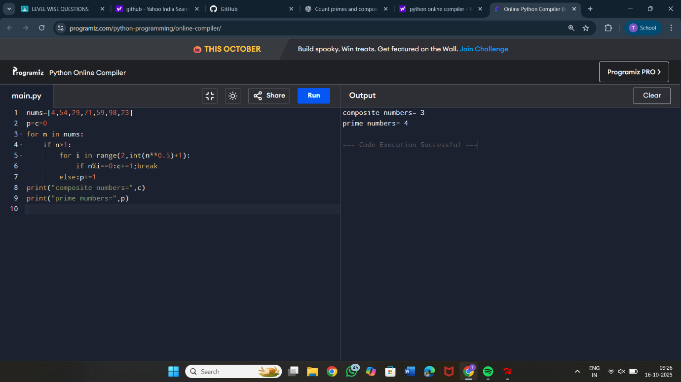

2. Sum of daigonal matrix
Sample input: [1 2 3 4 5 6 7 8 9]
Output: diagonal elements are 1,5,9
Sum of diagonal elements=15
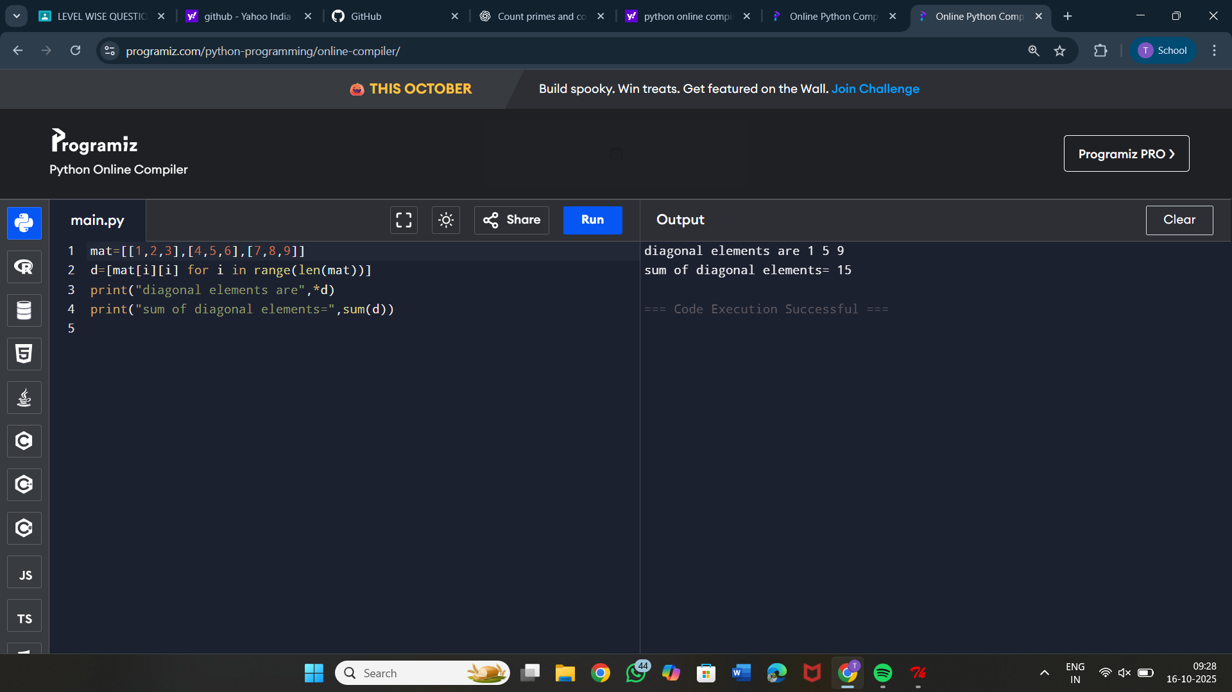

3. Perfect number or not
Sample Input: 6
Output: it is a perfect number
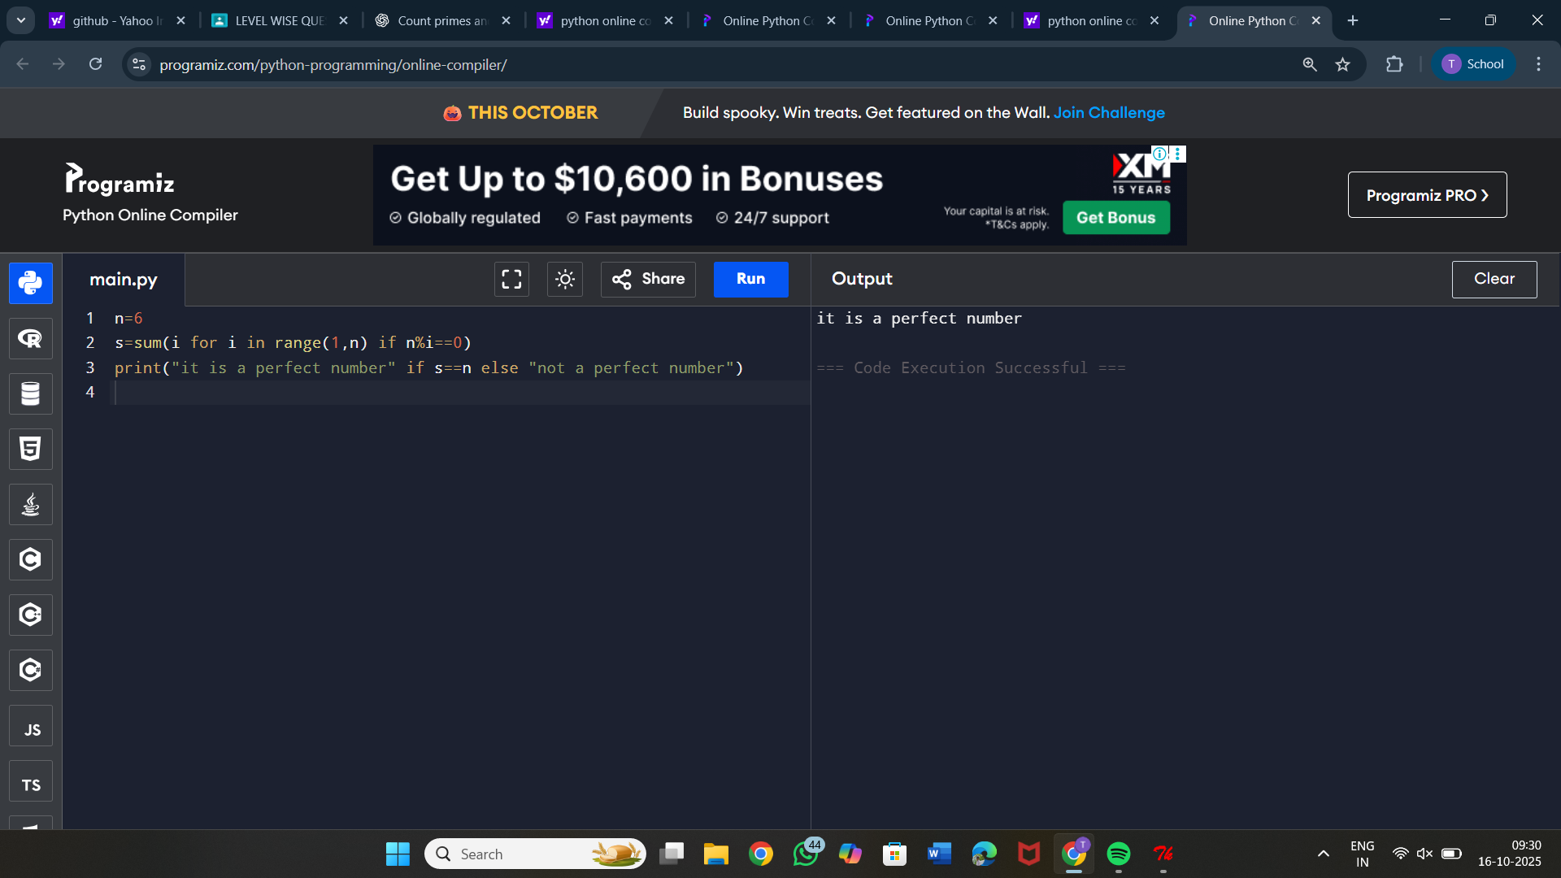

4. Write a program in Python to read the elements of a one-dimensional array,
compare the elements and find which are the largest two elements in a given
array.
Sample Input:
1 2 3 4 5 6 7
Output:
Largest two elements : 6 &amp; 7
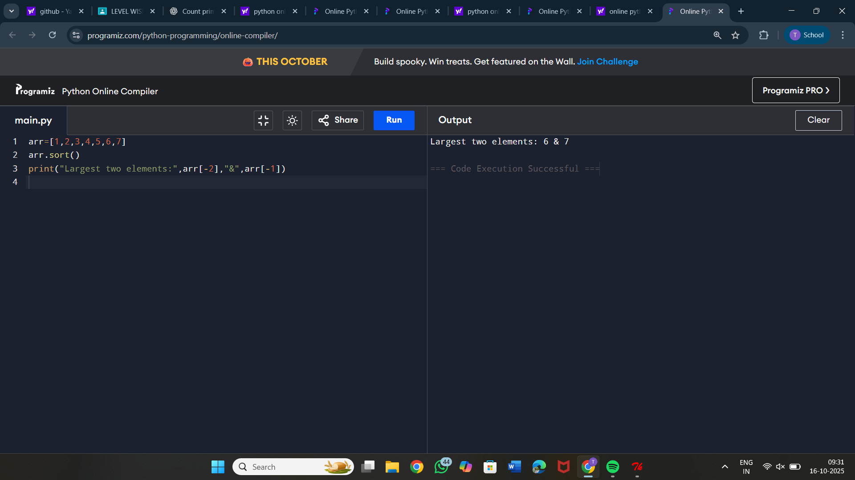

5. Find the Mth maximum number and Nth minimum number in an array and
find the sum and difference of it.
Sample Input:
Array of elements = {14, 16, 87, 36, 25, 89, 34}
M = 1
N = 3
Output:
1st Maximum Number = 89
3rd Minimum Number = 25
Sum = 114
Difference = 64
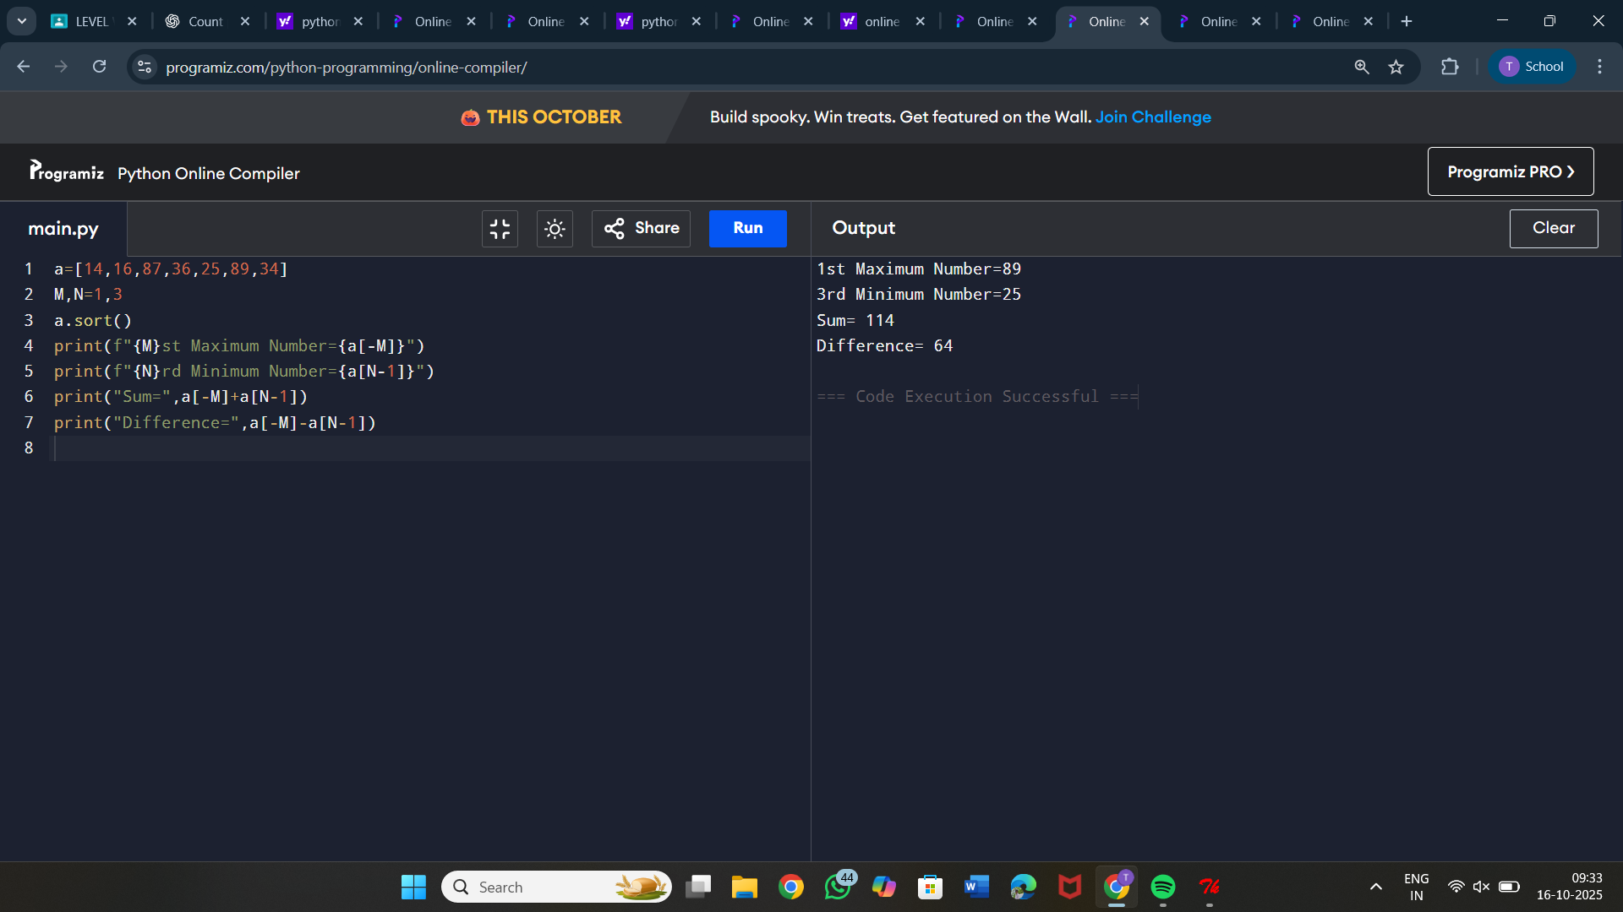

6. Find GCD and LCM in Python
Sample Input &amp; Output:
LCM of 15 and 20 is 60
The gcd of 60 and 48 is : 12
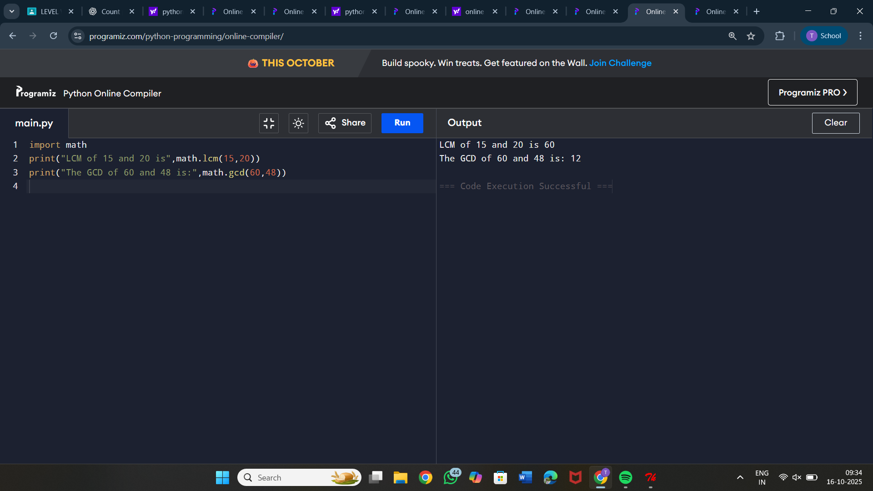

7. Write a Python program to display customer name mobile number and cost of
the purchase.calculate the discount and find the total amount to be paid.
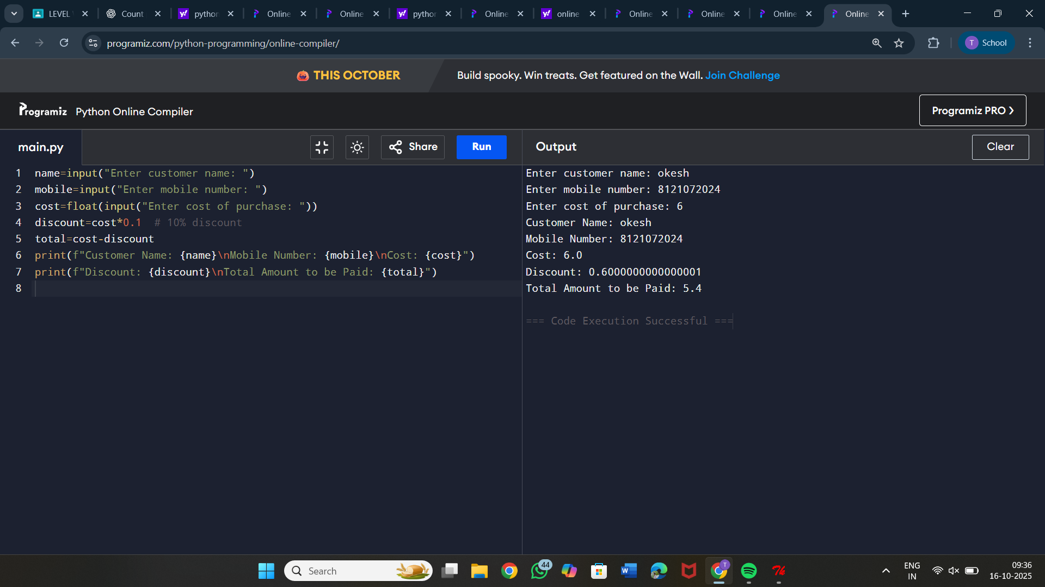

8. Write a Python program to find largest 2nd maximum in array
Sample Input:
a={1,6,4,2}
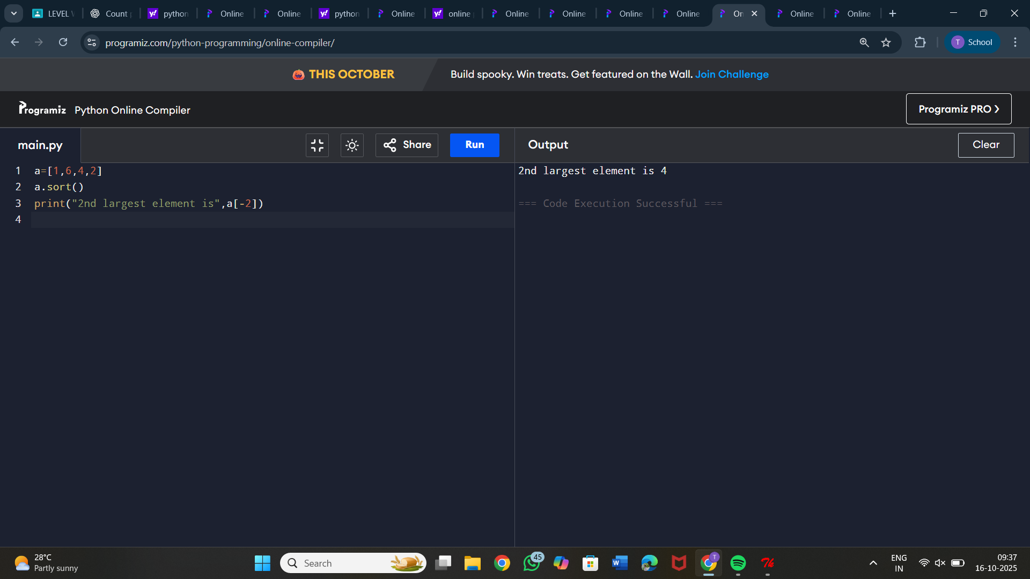
Output:4

9. You are give with an array which contains integer element. Sort the elements
in non-increasing order and print the middle element of the array.
Sample Input:
arr = {90,-90,80,66,78,10}
Output:
{-90,10,66,78,80,90}
Mid-element:66
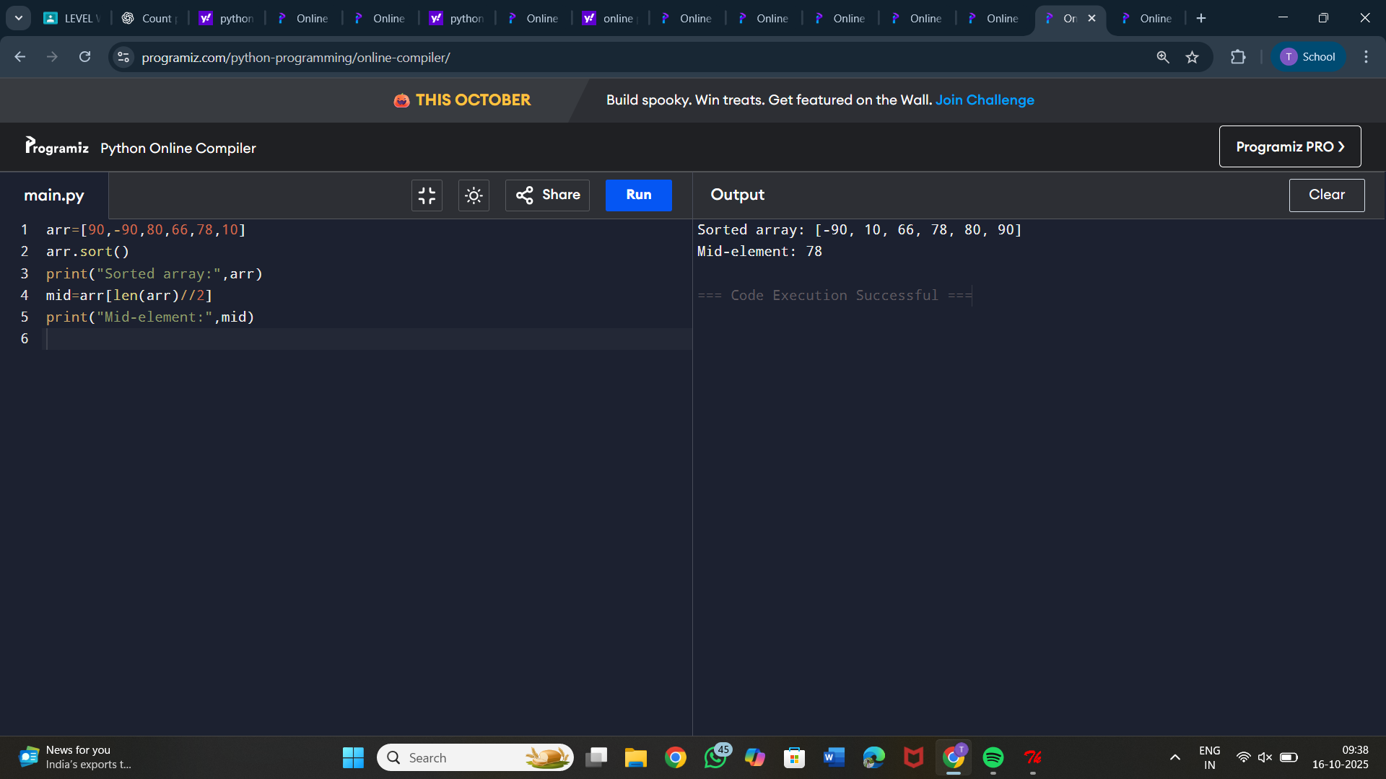

10. Write a python program to print multiplication of 3 matrices.
First matrix elements:
1 1 1
2 2 2
3 3 3
Second matrix elements
1 1 1
2 2 2
3 3 3
Third matrix elements
1 1 1
2 2 2
3 3 3
multiplication of the matrix:
36 36 36
72 72 72
108 108 108
